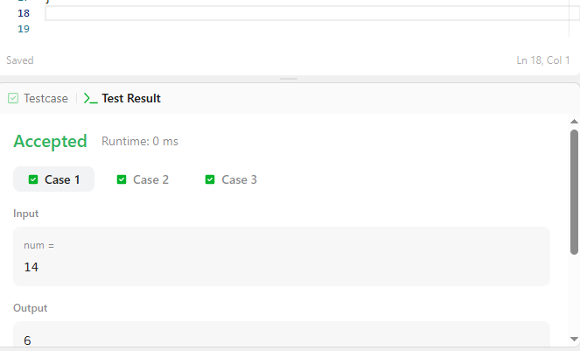

CODE-

int numberOfSteps(int num) {
int count = 0;

while (num > 0) {
if (num % 2 == 0) {
num = num / 2;
}
else {
num = num - 1;
}

count++;
}

return count;
}

LINK-

https://leetcode.com/problems/number-of-steps-to-reduce-a-number-to-zero/

